1 - 4 – Inverses – Teaching Set 1
1.
a). Discuss only—don’t write: Say I have $f\left(x\right)=2{\left(x+3\right)}^{3}-4$ and $g\left(x\right)=\sqrt[3]{x-4}-3$.
You notice $f\left(-1\right)=12$ and $g\left(12\right)=-1$. Your friend says: “they undo each other! They’re inverses!”
What’s the fastest way you can demonstrate to them that they’re not actually inverses? (What might be some other ways you could do it that are less fast?)
b). Find the equation for $f\left(g\left(x\right)\right)$.
c). What should $f\left(g\left(x\right)\right)$ have been if f and g are really inverses? Why?
d). Find the real inverse function for f. Label it $f^{-1}\left(x\right)=…your equation…$
e). Verify it works by finding $f\left(f^{-1}\left(x\right)\right)$ using your equation from d.

2. Find the inverse of each.
a. $h\left(x\right)=\frac{-6}{x+2}$ b. $f\left(x\right)=4^{2-x}$ c. . $f\left(x\right)=3⋅4^{2-x}+1$
d. $f\left(x\right)=\frac{2x+3}{x-1}$
[ hint: if you get stuck, think “I want all the y things on one side, and all the x things on the other. Then you can factor y out of the y-things and go from there ]

3. Assume both f(x) and g(x) have valid inverse functions defined for all real inputs. The table below shows the input and output values of f(x) and g(x) for some specific values.
x | -4 | -3 | -2 | -1 | 0 | 1 | 2 | 3 | 4
f(x) | -7 | -6 | -4 | -3 | -1 | 0.5 | 3 | 9 | 13
g(x) | 6 | 4 | 3 | 1 | 0 | -3 | -4 | -13 | -26
For each, write the answer or “Unknown” if it can’t be determined from the given information
a). f(0) = ___ b) $f^{-1}\left(3\right)$ = _____ c). $f^{-1}\left(0\right)=$ c). $[f o g](2)$ = d). $g^{-1}\left(-3\right)=$
e). Are f and g inverses? How can you tell?
f). You might think that $f\left( f^{-1}\left( 2 \right)\right)=not enough info to know$ because it’s not in the table. But you actually do know it, because I told you f has a valid inverse. What is it and why?

1 - 4 – Inverses – Solutions
1a). Say I have $f\left(x\right)=2{\left(x+3\right)}^{3}-4$ and $g\left(x\right)=\sqrt[3]{x-4}-3$. You notice $f\left(-1\right)=12$ and $g\left(12\right)=-1$.
Your friend says: “they undo each other! They’re inverses!” How can you know they actually aren’t?
The problem is that $f(x)$ and $g\left(x\right)$don’t undo-each other for other inputs. For example if x = 0: f(0) = 14, and g(14) = $\sqrt[3]{10}-3$ which clearly isn’t back to 0 again. Other ways you could tell might be to graph both and see that they aren’t reflections around y = x. Or you could find $f\left(g\left(x\right)\right)$ as you’ll do below.
b). Find the equation for $f\left(g\left(x\right)\right)$.
$f\left(g\left(x\right)\right)=2{\left(\left(\sqrt[3]{x-4}-3\right)+3\right)}^{3}-4$ $2{\left(\sqrt[3]{x-4}\right)}^{3}$ $2(x-4)$ so $f\left(g\left(x\right)\right)=2x-8$
c). If f and g undo each other, we’d expected $f\left(g\left(x\right)\right)→x$ because that’s what inverse functions do. Think about this as saying “whatever g turned x into, f takes that input and undoes the process to turn it back into x again”
d). Find the real inverse function for f.
Let’s swap x and y to solve: $x=2{\left(y+3\right)}^{3}-4$ $\frac{x+4}{2}={\left(y+3\right)}^{3}$ $\sqrt[3]{\frac{x+4}{2}}=y+3$ $y=\sqrt[3]{\frac{x+4}{2}}-3$
e). Verify it works by finding $f\left(f^{-1}\left(x\right)\right)$ using your equation from c.
$f\left(f^{-1}\left(x\right)\right)=2{\left(\sqrt[3]{\frac{x+4}{2}}-3+3\right)}^{3}-4$ $2{\left(\sqrt[3]{\frac{x+4}{2}}\right)}^{3}-4$ $2\left(\frac{x+4}{2}\right)-4$ $\left(x+4\right)-4$ x

2. Find the inverse of each. For each of these, we can swap x and y and then isolate y.
a. $h\left(x\right)=\frac{-6}{x+2}$
$y=\frac{-6}{x+2}$ $x=\frac{-6}{y+2}$ $x\left(y+2\right)=-6$ $xy+2x=-6$
$xy=-6-2x$ $y=\frac{-6-2x}{x}$. You could also write it as: $y=-\frac{6}{x}-2$
So: $h^{-1}\left(x\right)=\frac{-6-2x}{x}$ or $h^{-1}\left(x\right)=-\frac{6}{x}-2$
b. $f\left(x\right)=4^{2-x}$
$y=4^{2-x}$ $x=4^{2-y}$ $\log_{4}{x}=2-y$ $y=2-\log_{4}{(x)}$
So: $f^{-1}\left(x\right)=2-\log_{4}{(x)}$

c. . $f\left(x\right)=3⋅4^{2-x}+1$
$y=3⋅4^{2-x}+1$ $x=3⋅4^{2-y}+1$ $x-1=3⋅4^{2-y}$ $\frac{x-1}{3}=4^{2-y}$
$\log_{4}\left(\frac{x-1}{3}\right)=2-y$ $y=2-\log_{4}\left(\frac{x-1}{3}\right)$
So: $f^{-1}\left(x\right)=2-\log_{4}{(\frac{x-1}{3})}$

d. $f\left(x\right)=\frac{2x+3}{x-1}$
$y=\frac{2x+3}{x-1}$ $x=\frac{2y+3}{y-1}$ $x\left(y-1\right)=2y+3$ $xy-x=2y+3$
At this point, move all the terms with y to one side, and all the other terms to the other side. The idea is that we want to isolate y, so let’s get all the y things together.
$xy-x-2y=3$ $xy-2y=3+x$
Now we can factor out the y that’s in all the terms on the left.
$y\left(x-2\right)=3+x$ $y=\frac{3+x}{x-2}$
So: $f^{-1}\left(x\right)=\frac{x+3}{x-2}$

3. Assume both f(x) and g(x) have valid inverse functions. The table below shows the input and output values of f(x) and g(x) for some specific values.
x | -4 | -3 | -2 | -1 | 0 | 1 | 2 | 3 | 4
f(x) | -7 | -6 | -4 | -3 | -1 | 0.5 | 3 | 9 | 13
g(x) | 6 | 4 | 3 | 1 | 0 | -3 | -4 | -13 | -26
For each, write the answer or “Unknown” if it can’t be determined from the given information
a). f(0) = -1 This one you can find the column where x = 0 and see that f outputs -1.
b) $f^{-1}\left(3\right)$ = 2 Here it’s “backwards”. We know that $f^{-1}(3)$ means that f will output 3 for some input. Visually scan the $f(x)$ row until you find 3. You see that when x = 2, $f\left(2\right)=3$. That means $2=f^{-1}(x)$.
c). $f^{-1}\left(0\right)=unknown$ We might guess that an x-value between 0 and 1 should give an output of 0, but without the full function we don’t really know.
c). $[f o g](2)$ = -7 Here $f\left(g\left(2\right)\right)$ we can do one step at a time. $g(2)$ is -4. Then $f(-4)$ is -7.
d). $g^{-1}\left(-3\right)=1$ This is the g function in reverse. We know $g\left(something\right)=-3$. Scanning the g outputs, we see that $g\left(1\right)=-3$. So $g^{-1}\left(-3\right)=1$.
e). If someone says: “hey, are f and g inverses?” how can you convince them yes or no ?
You can test almost any value to show that f and g don’t actually undo each other. For example f(0) = -1, but g(-1) is 1, not 0. So that’s enough to decide that they’re not.
f). You might think that $f\left( f^{-1}\left( 2 \right)\right)=not enough info$ .
Since the problem says f has a valid inverse, we know that inverse must undo the f function and vice versa. So even though we don’t know what number $f^{-1}(2)$ is, we KNOW that f will turn it back into 2 again. So $f\left(f^{-1}\left(2\right)\right)=2$.
Note that you can only assume that because we know that f has a valid inverse whose domain is all real values.

1 - 4 – Inverses – Teaching Set 2
1). [C/P]. What’s the big idea of imposing a domain restriction?

Consider $f(x)=x^{2}-3$
a). Agree out loud (no need to write): why doesn’t f have an inverse function? What can you do with f that will let you find an inverse function?
b). Write down 3 different domain restrictions that would make f’s inverse be a function.
c). Write 1 domain restriction that wouldn’t result in f’s inverse being a function.
d). Ok, here’s my domain restriction: $f\left(x\right)=x^{2}-3$ for $x>1$. Find $f^{-1}(x)$ and give its domain.

2). Here are several functions with restricted domains. Find the inverse function and give its domain.
  - Given $q\left(x\right)={(x-2)}^{2}-1$ restricted to $x≤1$, find the equation of $q^{-1}$ and its domain.
  - $f\left(x\right)=\sqrt{2+5x}$ . Find $f^{-1}(x)$ and its domain. [ hint: it’s NOT all real numbers ]

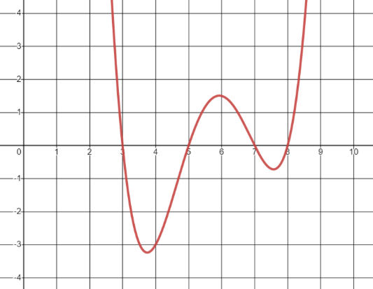
3). Consider g(x) shown here. Mark T (true) or F (false) for each statement. Be sure you could say why.
T/F g(x) is invertible (its inverse exists) if we restrict its domain to [0, 3]
T/F g(x) is invertible if we restrict its domain to $5<x<7$
T/F g(x) is invertible if we restrict its domain to $4<x<5.5$
T/F g(x) is invertible without a domain restriction
T/F g(x) is invertible if we restrict its domain to $6<x$

4).
a). $f\left(x\right)=2^{\left|x\right|}$, restricted to $2≤x≤4$, find $f^{-1}$ and its domain.
[ hint: you know enough to do this. Read the whole problem and ask yourself: what’s the part of the problem that feels difficult? Ask yourself: for the domain I’m looking at, is it actually a problem? Remember this general idea. A great problem-solving strategy is to look at just the part of the problem that makes it seem difficult, and figure out how to deal with just that part.]

b). Ok, now try and find the inverse of f(x) when restricted to $-4≤x≤-2$. Write $f^{-1}$ and its domain.

1 - 4 – Inverses – Teaching Set 2 – Solutions
1). [C/P]. What’s the big idea of imposition a domain restriction?
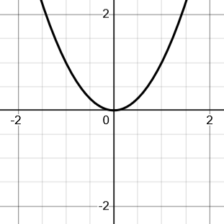
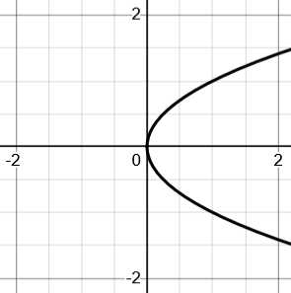
The big idea is that many functions, if you invert them, will fail the vertical line test, so the inverses aren’t functions.
inverse

Here, the inverse of $f\left(x\right)=x^{2}$ is a sideways parabola.
If we ask what $f^{-1}(1)$ is, there are two outputs: $f^{-1}\left(1\right)=1$ but $f^{-1}\left(1\right)=-1$ also.

Since functions can only have a single output, $f^{-1}$ isn’t a function.

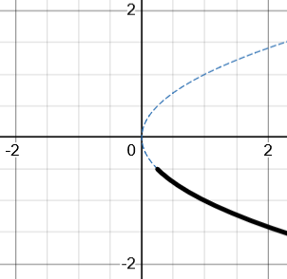
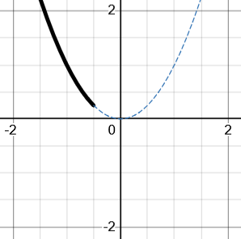
The big idea of a domain restriction is that we can choose to restrict the domain of the original function so when we find the inverse, it will be a valid function. For example, if I find the inverse of $f\left(x\right)=x^{2}$ when $x≤-\frac{1}{2}$, it looks like this.
inverse

Now when I reflect $y=x^{2}$ around $y=x$, the inverse function only includes the bold bottom part because I restricted the domain of the original function.

Now the inverse really is a function and $f^{-1}(1)$ only has the single output $f^{-1}\left(1\right)=-1$

That’s not the only way I could restrict the domain. There are lots of ways to do it that would produce valid inverse functions. That’s what the rest of the problem is about.

Consider $f(x)=x^{2}-3$
a). Agree out loud (no need to write): why doesn’t f have an inverse function? What can you do with f that will let you find an inverse function?

Since it’s a parabola, reflecting it around y = x will make a sideways parabola, which isn’t a function because it has 2 outputs for each input. Put differently, if you try and find the inverse with an equation you get $y=±\sqrt{x+3}$ and the $±$ is what make two outputs for a single input. The thing we can do is restrict the domain of the original function so the reflected inverse will only have one output for each input and therefore be a function.

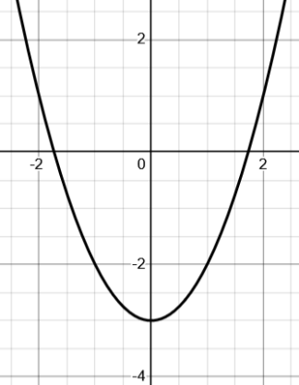
b). Write down 3 different domain restrictions that would make f’s inverse be a function.

$x≥0$, $x>100$, $x≤-1$ and many many others will all work.
Any interval that’s only on one side of the vertex will work.

c). Write 1 domain restriction that wouldn’t make f’s inverse a function.

$x≥ -2$ or $x<10$ or many others. Any interval that includes the “hump” of the vertex won’t work. Make sure you can imagine why that makes sense!

d). Ok, here’s mine: $f\left(x\right)=x^{2}-3$ for $x>1$. Find $f^{-1}(x)$ and give its domain.
To find the inverse, swap x and y and then isolate y. That gives $f^{-1}\left(x\right)=\sqrt{x+3}$.

But what’s the domain? Imagine it graphically including the original domain restriction.
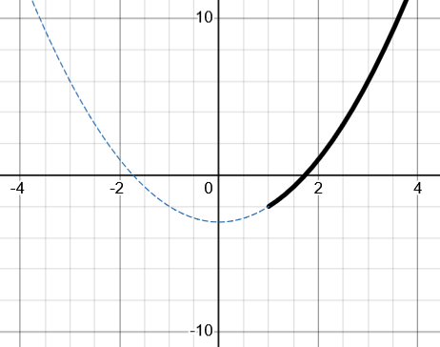
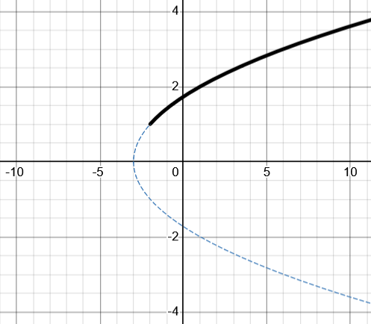
inverse
$$(1,-2)$$
$$(-2,1)$$
$f\left(x\right)=x^{2}-3$ for $x>1$
$$f^{-1}\left(x\right)=\sqrt{x+3}$$

The end-point where the domain restriction starts has coordiantes $(1,-2)$. The inverse function reverses x and y, so the point $(1,-2)$ becomes $(-2, 1)$ on the inverse. Therefore, you can see the domain is $x>-2$.
One more visual connection you can make. When x and y swap roles, all the concepts associated with x also swap with concepts associated with y. So domain (associated with x) swaps with range (associated with y). Look at it this way:


inverse
$$(1,-2)$$
$$(-2,1)$$
$f\left(x\right)=x^{2}-3$ for $x>1$
$$f^{-1}\left(x\right)=\sqrt{x+3}$$
Range: $y>-2$
domain: $x>-2$

2). Here are several functions with restricted domains. Find the inverse function and give its domain.
a. Given $q\left(x\right)={(x-2)}^{2}-1$ restricted to $x≤1$, find the equation of $q^{-1}$ and its domain.
Using the same approach, you get $q^{-1}\left(x\right)=2-\sqrt{x+1}$ on $x≥0$

b. $f\left(x\right)=\sqrt{2+5x}$ . Find $f^{-1}(x)$ and its domain.
Finding the inverse is just the same:
$y=\sqrt{2+5x}$ $x=\sqrt{2+5y}$ $x^{2}=2+5y$ $x^{2}-2=5y$ $y=\frac{x^{2}-2}{5}$
You might think: “oh! $f^{-1}\left(x\right)=\frac{x^{2}-2}{5}$ is already a function, so there’s no need to restrict the original. This is just the answer”.
The reason that’s not quite right is because the original square root function already has a restricted domain.
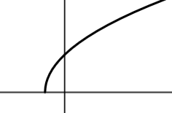
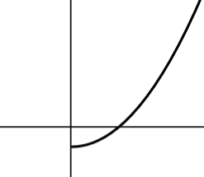
Even if you’re not too sure what it looks like, you could see it’s some horizontal transformation of $y=\sqrt{x}$. So in your mind you can see it as the graph on the left.
$$\left(-?,0\right)$$
$$\left(0,-?\right)$$
$$f\left(x\right)=\sqrt{2+5x}$$
$$f^{-1}\left(x\right)=\frac{x^{2}-2 }{5}$$
If you imagine reflecting this around $y=x$, you’ll get the graph on the right.
Notice that we don’t actually need to know what that x-intercept is for the original function. It’s enough to realize that it’s the upper half of the sideways parabola which will reflect to give a domain of $x≥0$.

So the final answer is: $f^{-1}\left(x\right)=\frac{x^{2}-2}{5}$ for $x≥0$


3). Consider g(x) shown here. Mark T (true) or F (false) for each statement.
To solve these, you could hold your hands up and block the parts of the curve that aren’t in the domain. The imagine reflecting it and see if it passes the vertical line test.
g(x) is invertible (its inverse exists) if we restrict its domain to [0, 3] TRUE
g(x) is invertible if we restrict its domain to $5<x<7$ FALSE
g(x) is invertible if we restrict its domain to $4<x<5.5$TRUE
g(x) is invertible without a domain restriction FALSE
g(x) is invertible if we restrict its domain to $6<x$ FALSE

4). a). $f\left(x\right)=2^{\left|x\right|}$, restricted to $2≤x≤4$, find $f^{-1}$ and its domain
The $2^{|x|}$ might feel scary like you can’t imagine it. You could, of course, try and figure out what it looks like (which is also a good exercise).
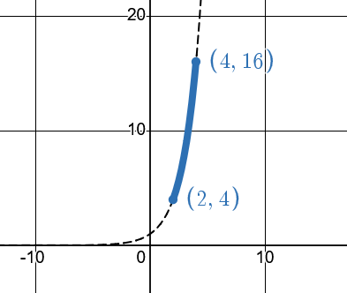
However, we only care about the part of the graph when x is between 2 and 4. Since those are positive x values, $|x|$ is just the same as x.
So for the interval we care about $2^{|x|}$ is the same as $2^{x}$
That makes us free to invert $y=2^{x}$ giving $f^{-1}\left(x\right)=log_{2}(x)$.
But on what domain? It helps to imagine the graph. The two end-points are at (2, 4) and (4, 16). That means the reflected inverse will have endpoints at (4, 2) and (16, 4).
So the final answer is: $f^{-1}\left(x\right)=\log_{2}{(x)} for 4≤x≤16$

b). Ok, now try and find the inverse of f(x) when restricted to $-4≤x≤-2$. Write $f^{-1}$ and its domain.
Now we do need to tackle what $2^{|x|}$ is like when x is negative. There are several ways to make sense of this for yourself.
One is to try and write $|x|$ in a form that’s easier to deal with.
If $\left|x\right|$ turns a negative x-value positive, you could realize that $-x$ will also turn a negative x-value positive.
So when $x<0$, $2^{|x|}$ is the same as $2^{-x}$.
This can let you find the inverse: $y=2^{-x}$
$x=2^{-y}$ $\log_{2}\left(x\right)=-y$ $y=-\log_{2}{(x)}$
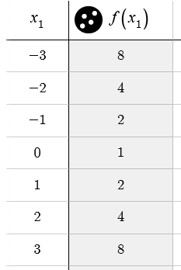
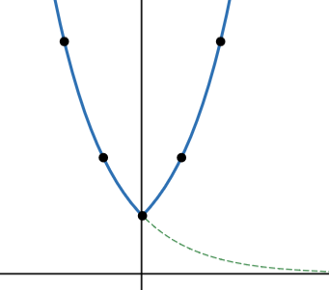
If that didn’t occur to you, you could try and plot some values and imagine the graph (shown here), but that by itself doesn’t help you find the equation of the inverse.
$$2^{|x|}$$
$$x$$
$$y=2^{-x}$$
What if you try and tackle it directly?
If you try and work out the inverse:
$x=2^{|y|}$ $\log_{2}{x}=|y|$
How do you “undo” absolute value? If y is positive, then $|y|$ is just y so there’s nothing to undo. If y is negative, then to “undo” $|y|$ you need a way to turn the positive output back into the negative input. $-y$ will do that.
So: $\log_{2}\left(x\right)=-y$ giving $y=-\log_{2}{(x)}$
Just like last time, imagine the end-points of the interval we care about.
The end-points of the f(x) graph are at $(-4,16)$ and $(-2,4)$. So the reflected inverse will have end-points at $(16, -4)$ and $(4, -2)$. This gives a final answer of $f^{-1}\left(x\right)=-\log_{2}\left(x\right) for 4≤x≤16$.

